1ai)

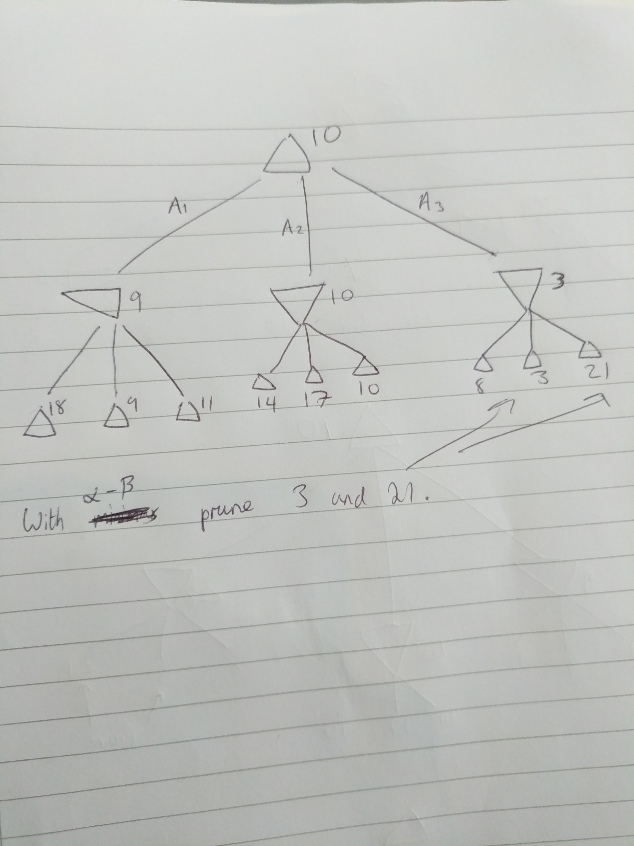

ii) When you start to traverse the 3rd branch, you visit the leaf node with value 8 first. You can then note that the 3rd branch’s value can only be <=8 as it’s trying to minimise. So, it’s not worth looking at any more of that branch because when it comes to maximising at the root you’ve already got 10 which is bigger than 8.

I don’t think the rest of the paper can come up